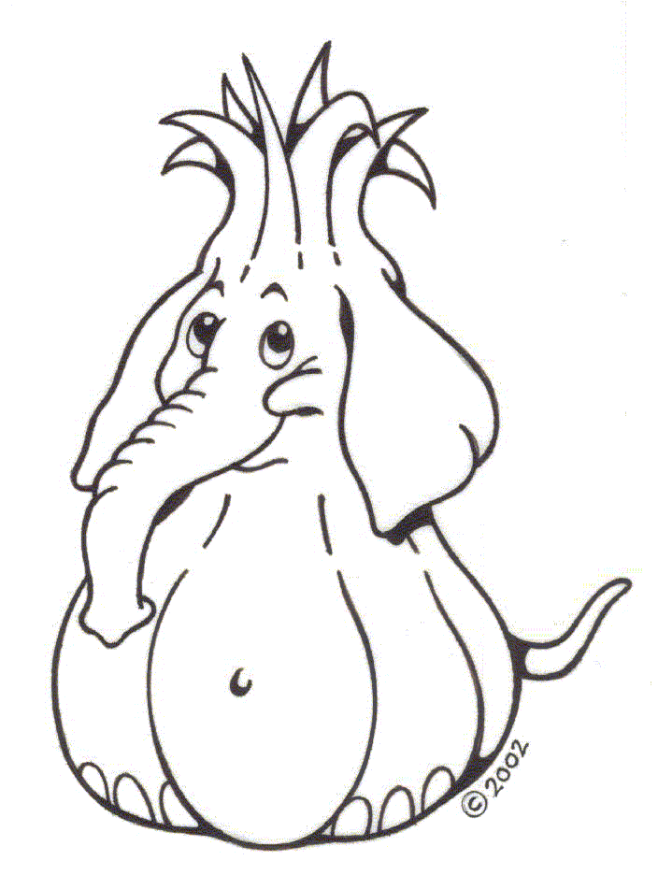
North Plains Elephant Garlic Festival
ARTS & CRAFTS APPLICATION
Friday, Saturday & Sunday, August 7th, 8th & 9th
Incomplete applications will be returned
Application Postmark Deadline: March 16, 2015
Mail to Sherrie Simmons 30796 NW Brooking Ct. North Plains, OR 97133
Make Checks Payable to NPEA
Stinkee is Back
and here to stay!

Business Name _________________________________________________________________________
Artist Name ____________________________________________________________________________
Address_____________________________________ City ___________________ State____ Zip _______
Home (___)__________________________________ Cell (___)__________________________________
Business (___)_______________________________ Fax (___)___________________________________
Email______________________________________ Website____________________________________
NO COMMERCIAL OR IMPORTED ITEMS ARE ALLOWED AT THE NORTH PLAINS ELEPHANT GARLIC FESTIVAL. I UNDERSTAND THESE TERMS AND I WILL MAKE ALL PRODUCTS I WILL SELL AT THE EVENT. (INITIAL)_____
Select the jury category that best represents your work. Your Event booth inventory must represent this single jury category and be consistent in content, form and quality with the submissions shown in your photos reviewed by the jury.
____ Bath, Body & Candles ____ Gift Food ____ Leather ____ Refurbished items
____ Ceramics/Pottery ____ Glass ____ Metal ____ Wearable’s-Adult
____ Children’s items/clothing ____ Home & Garden ____ Painting/Drawing ____ Wood
____ Fiber Art ____ Jewelry ____ Photography ____ Other (describe)
Describe your work (medium, materials, size, character, genre, etc.):

My work ranges in price from $_______ to $_______. The majority of my items are priced at $_______.
Enclosed are 2 current color photos plus a booth photo which represent the products you intend to offer at North Plains Elephant Garlic Festival. Number your prints to correspond to the list below. (slides will not be accepted). If you are a returning Art vendor from 2014, please send photos only of any new items you will be offering.
Photo 1 ______________________________________________________________________________
Photo 2 ______________________________________________________________________________
Were you an Arts Vendor in 2014? _____NO ____ YES
How many 10x10 booth spaces would you like to have _________. (10x10 is $125, 10x20 is $240.00)
Electricity required _____yes _____no. Please see electricity regulations on page 4. What will electricity be used for?____________________________________________________________________________
Handicapped Parking needed yes______ no______. Number of parking spaces required for the duration of the event __________.
Vehicle(s) to be parked in Vendor Parking is: ________________________________________________
Dimensions of space needed for vehicle: __________________________________ (do not leave blank)
Please note: North Plains Elephant Garlic Festival has very limited vendor parking. If you have a motor-home or trailer, you will be provided with just enough space for a pop-out if that is what you have. You will not be provided room for a canopy. We are not a regular campground and are short on space to be able to provide parking space let alone camping space. If you feel you need to have more room then you are welcome to contact Loch Lolly Christmas Forest which is up the road about 4 miles. They are willing to allow more space for camping and Motorhome/trailer parking there. Phone: 503-647-2619.
CHECKLIST FOR A COMPLETE APPLICATION PACKAGE:
- Complete and sign the application, pages 1 and 3.
- Retain Rules & Regulations, page 4 and 5 for your records (please bring with you to the event).
- Enclose your booth fee of $125 for 10x10 or $240 for 10x20 space and a separate check for $25.00 which is your refundable cleaning deposit. Please do not combine the cleaning fee with the booth fee.
- MAKE CHECKS PAYABLE TO NPEA and mail to Sherrie Simmons 30796 NW Brooking Ct. North Plains, Oregon 97133
- Enclose 2 RECENT product photos which represent the products you intend to offer at the North Plains Elephant Garlic Festival. (NOTE: Applicant photos are retained by the Arts Committee for all Artists participating in the North Plains Elephant Garlic Festival. If you want your photos returned after the event, enclose a self-addressed stamped envelope with correct amount of postage).
- Enclose a color photo of your booth as it will be stocked for The North Plains Elephant Garlic Festival, or explain booth in writing if you do not have a picture.
- Mandatory that you include information of how many vehicles you will need to park, including the dimensions of bigger vehicles such as RV’s, trailers, and vans.

The APPLICANT shall indemnify and hold North Plains Events Association, it’s Board Members and The City of North Plains and its agents, employees and/or officers, harmless from and shall process and defend at its own expense any and all claims, demands, suits, at law or equity, actions, penalties, loss, damages, or costs, of whatsoever kind or nature, brought against the North Plains Events Association, its Board Members and The City of North Plains arising out of, or in connection with, or incident to, the execution of this Agreement and/or applicant’s performance or failure to perform any aspect of this Agreement; provided however, that If such claims are caused by or result from the concurrent negligence of the North Plains Events Association, it’s Board Members and The City of North Plains, its agents, employees, and/or officers, this indemnity provisions shall be valid and enforceable only to the extent of the negligence of the Applicant; and provided further, that nothing herein shall require the Applicant to hold harmless or defend the North Plains Events Association, its Board Members and The City of North Plains, its agents, employees, and/or officers for damages or loss caused by the North Plains Events Association, its Board Members and The City of North Plains sole negligence. The Applicant expressly agrees that the indemnification provided herein constitutes the contractor’s waiver of immunity. This waiver has been mutually negotiated by the parties. The provisions of this section shall survive the expiration or termination of this Agreement.
Applicant has read and understands the Application and Rules & Regulations, Page 4 and 5, and will abide by them throughout their association with North Plains Elephant Garlic Festival. It is understood that North Plains Elephant Garlic Festival reserves the right to close, without refund, any participant (vendor booth) who is not complying with these regulations.

Applicant Signature _____________________________________________Date__________________
Print Name____________________________________________________Title__________________
Address:____________________________________________________________________________
___________________________________________________________________________________
Phone Number:______________________________________________________________________

DEADLINE FOR COMPLETE APPLICATION PACKAGE TO BE POSTMARKED by March 16th, 2015.
Payment for the booth space can be made with a check or money order.

This portion left blank intentionally.

Arts & Crafts Rules and Regulations
Application Deadline
All applicants must submit a Complete Application Package with their booth fee and a separate $25 refundable cleaning deposit by March 16th, 2015. Your checks will be returned if you are not accepted into the event. This will not occur until the end of May 2015.
Booth Fee
Full payment is due with application. The Arts & Crafts Booth Space Fee is $125 for a 10x10, and $240 for a 10x20 space. A separate check of $25 is required as a cleaning deposit. (This will be returned at the end of the event if booth space is clean after tear down). Do not pay booth fee and cleaning fee on one check. Note: 2 separate checks are required.
Electricity
Electricity is available only on the outside parameter of the Arts & Crafts grounds and only for artists in action or with a need for a cash register or lighting for their product. Most people want this space but it is very limited. Preference is given to food vendors and the elderly.
Hours of Operation
Event hours are from 12 noon - 8 pm Friday, 10 am – 8 pm Saturday, and 10 am - 6 pm Sunday.
You may not close your booth prior to 6 pm on Sunday. Absolutely no vehicles allowed on the field prior to 6 pm on Sunday. If it is slow, you may begin to pack up within your space but you are not allowed to remove anything until 6 pm Sunday. If you leave prior to the end of the event, you will not be allowed to return as a vendor to the event the following year and you will forfeit your cleaning deposit.
Jury Selection
- Each year, all applications are juried on quality and originality within each jury category. Past participation does not guarantee acceptance.
- North Plains Elephant Garlic Festival reserves the right to refuse any application.
- Notification letters regarding acceptance will be mailed to applicants by May 15th, 2015. If you are not chosen to participate in the event your checks will be returned.
- A wait-list will be established in case of cancellations. Applications after the deadline are not eligible for the waitlist.
Merchandise
- Applications are only accepted from Artists who personally handcraft or embellish the items they sell and who can be present in their booth during the event operation hours.
- All merchandise must be consistent with the photos submitted with the application and reviewed by the jury. North Plains Elephant Garlic Festival does not accept product samples for the jury.
- Artist applications for imported, mass-produced or commercially manufactured items are not accepted.
- The event reserves the right to close any booth not adhering to these regulations.
- NOTE: It is not your job to go around and police the other booths.

Security
Booth structure and contents, including inventory, are the sole responsibility of the Artist. North Plains Elephant Garlic Festival and the City of North Plains do not assume any responsibility for injury to persons, loss or damage to any property of the Artists, including theft, accidents or acts of God. There will be night security walking /patrolling the grounds beginning on Thursday August 6th.
Restrictions
- Artists are not allowed to “rove” with their merchandise at any time nor hand out samples of anything outside of their booth.
- No smoking or alcoholic beverages are allowed within or in the vicinity of your booth. Smoking is allowed across the street from the park or at the smoking area in the beer garden only.
- The North Plains Elephant Garlic Festival name, logo and theme are trademarked. Any use must be pre-approved by the event Director.
- Absolutely No animals allowed in the event unless the animal is a medical assistance dog.
Set Up & Take Down
- Load in time will be between 10 am and 7 pm Thursday August 6th. Vehicles must be removed from the event field by 7:00 pm. Late arrivals must walk in their supplies. If you set up on Friday morning, 1) you may not drive onto the field, and 2) you must be ready to sell by Noon that day. No vehicles allowed on the event field after Thursday set up through Sunday 6:00 pm.
- Load out begins at 6 pm on Sunday August 9th. All booths, vehicles and vendor debris must be removed from the Event grounds by 9 pm Sunday August 9th.
- If booth area is not left clean at the end of the event, vendor will forfeit Cleaning Deposit.
- Art vendors responsible for their own insurance to cover their product.

